Name:______________________Date: ______________blk:_________

Anatomy & Physiology 12 Pineapple Lab Makeup Assignment

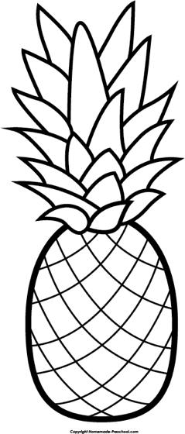
(A) Research Bromalin: Find out what type of enzyme it is and what it does.

(B) Find out what Gelatin is, describe it and what it’s used for.

(C) Investigate how it would act on Gelatin.

(D) Explain what would happen and why it happens if gelatin was added to:

1) Fresh Pineapple
2) Canned pineapple
3) Frozen pineapple

Reference all sources in APA.

______________________________________________________________________________

______________________________________________________________________________

______________________________________________________________________________

______________________________________________________________________________

______________________________________________________________________________

______________________________________________________________________________

______________________________________________________________________________

______________________________________________________________________________

______________________________________________________________________________

______________________________________________________________________________

______________________________________________________________________________

______________________________________________________________________________

______________________________________________________________________________

______________________________________________________________________________

______________________________________________________________________________

______________________________________________________________________________

______________________________________________________________________________

______________________________________________________________________________

______________________________________________________________________________

______________________________________________________________________________

______________________________________________________________________________

______________________________________________________________________________

______________________________________________________________________________

______________________________________________________________________________

______________________________________________________________________________

______________________________________________________________________________

______________________________________________________________________________

______________________________________________________________________________

______________________________________________________________________________

______________________________________________________________________________

______________________________________________________________________________

______________________________________________________________________________

______________________________________________________________________________

______________________________________________________________________________

______________________________________________________________________________

